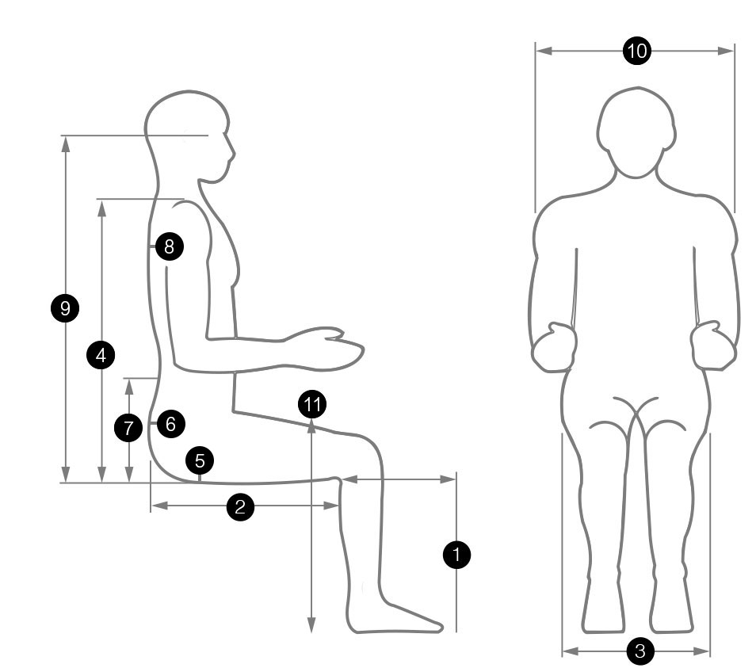
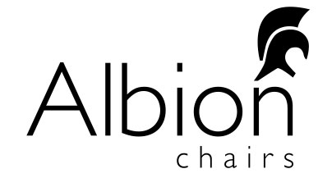
WORKSTATION ASSESSMENT
1 | Leg Height – seat gas lift req
2 | Thigh Length (seat depth)
3 | Hip Width (seat width)
4 | Shoulder Height
5 | Is Coccyx Cut-out req? CC
6 | Is Pelvic/Sacral Support req? SP
7 | Is Lumbar support? L2/LP/L2LP
8 | Is Thoracic Pump req? TP
9 | Is Headrest req? (Operator Eye Height)
10 | Multifunctional Arms? A3B/A5X/FA6
11 | Desk Height (to the underside of current desk)
Name of End User
Weight (kg / st.) if> than 120kgs
Height
Back Condition

Chair Recommendations
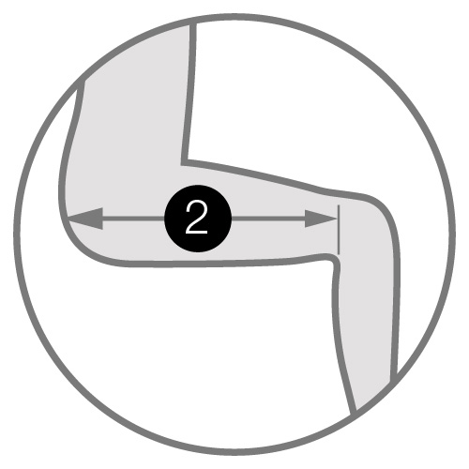
Manifestation (pain encountered + where)
(Mobile) phone number(s)
Email
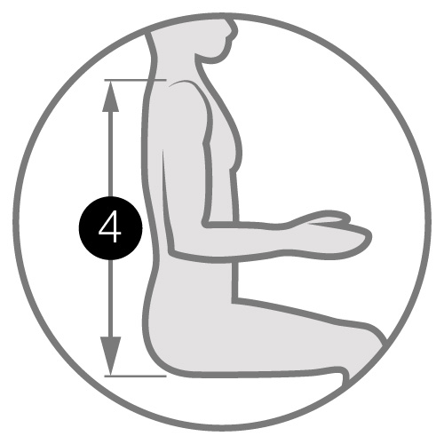
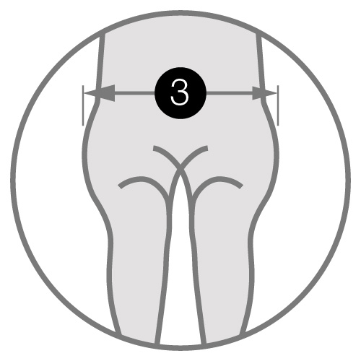
Bold = essential information for optimum fitting
No. of Hours / Week: FT/PT/HOME/OFFICE
Left / Right-handed:
Can you touch type:
Do you need to look at keyboard?
Desk Shape / Size:
Width x depth x height to underside
Screen Set-up:
SGL / DBL / HGT ADJ / Monitor Arm?
Keyboard Positioning:
Close / Away Reaching? / 90°
Mouse:
Wired / Remote / Ergo / RESTRICTED?
Document Layout: Do you need to
have documents around you or paperless?
Telephone Set-up:
Headset? Hold phone at the same time as typing?
Do you currently have a footrest?
Current Chair:
Adjustability:
Deskspace:
Tidy / clear?
Cable Management:
Lighting:
Legroom / Mobility:
Laptop:
Stand, etc.?
Eye Test / Varifocals:
Breaks:
Is There A Standard Fabric?
Photo of workplace
Notes
Fill out the editable form and email to sales@albionchairs.com

