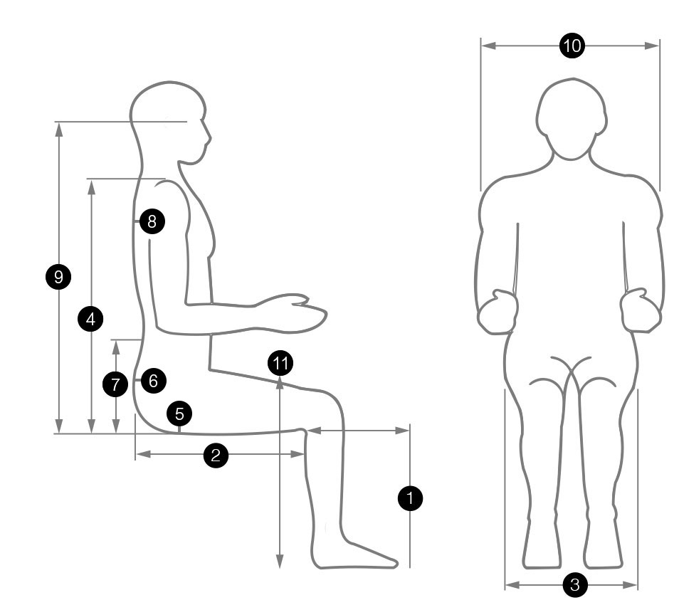
fitting your Spynamics chair
1 | Leg Height
2 | Leg Length (to back of knee)
3 | Hip Width
4 | Shoulder Height
5 | Coccyx Cut-out
6 | Pelvic/Sacral Support
7 | Lumbar Height (to centre of small of back)
8 | Thoracic Pump
9 | Headrest / Operator Eye Height
10 | Arms
11 | Desk Height (to the underside of current desk)
Name of End User
Weight (kg / st.)
Height
Back Condition

Chair Recommendations
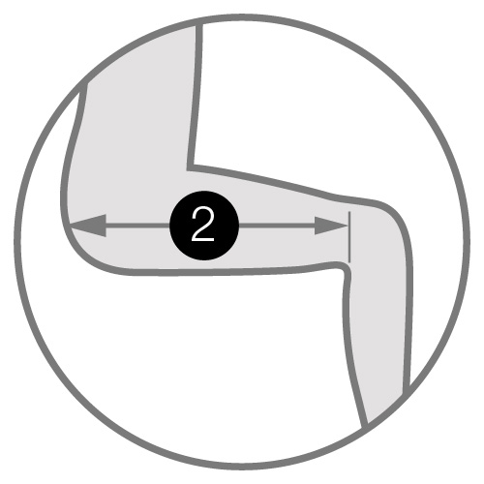
Manifestation (pain encountered + where)
Telephone number
Email
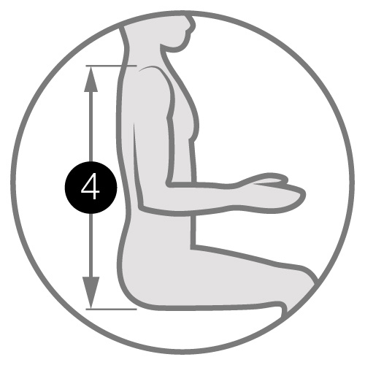
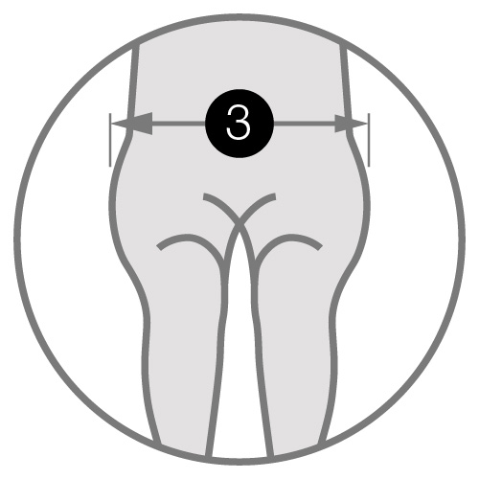
Bold = essential information for optimum fitting
No. of Hours / Week:
Left / Right-handed:
Can you touch type:
Do you need to look at keyboard?
Desk Shape / Size:
Width x depth x height to underside
Screen Set-up:
SGL / DBL / HGT ADJ / Monitor Arm?
Keyboard Positioning:
Close / Away Reaching? / 90°
Mouse:
Wired / Remote / Ergo?
Document Layout: Do you need to
have documents around you or paperless?
Telephone Set-up:
Headset? Hold phone at the same time as typing?
Do you currently have a footrest?
Current Chair:
Adjustability:
Deskspace:
Tidy / clear?
Cable Management:
Lighting:
Legroom / Mobility:
Laptop:
Stand, etc.?
Eye Test / Varifocals:
Breaks:
Is There A Standard Fabric?
Photo of workplace
Notes
Fill out the editable form and email to sales@albionchairs.com

