1* | Seat Height
2* | Seat Length
3* | Hip Width
4 | Operative Eye Height
5 | Elbow to Seat Height
6* | Shoulder Height
7 | Desk Height (to the underside)
8 | Armrest Width
Name of End User
Weight (kg/St.)
Height
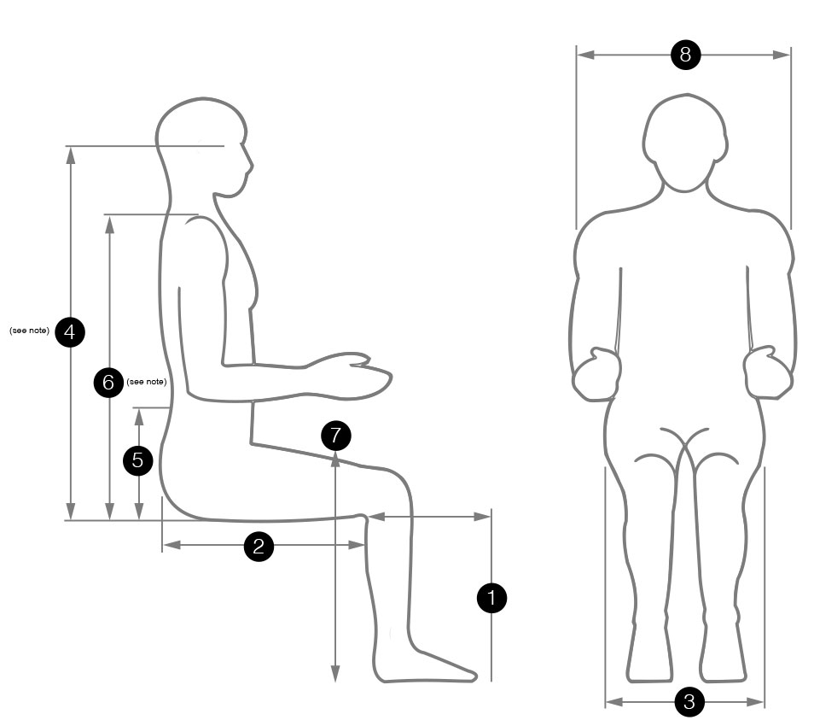
*essential information for optimum fitting
Fill out the form and fax back to 01494 474760
fitting your Spynamics chair

