

**Everyday/access**

t

to work seating solution

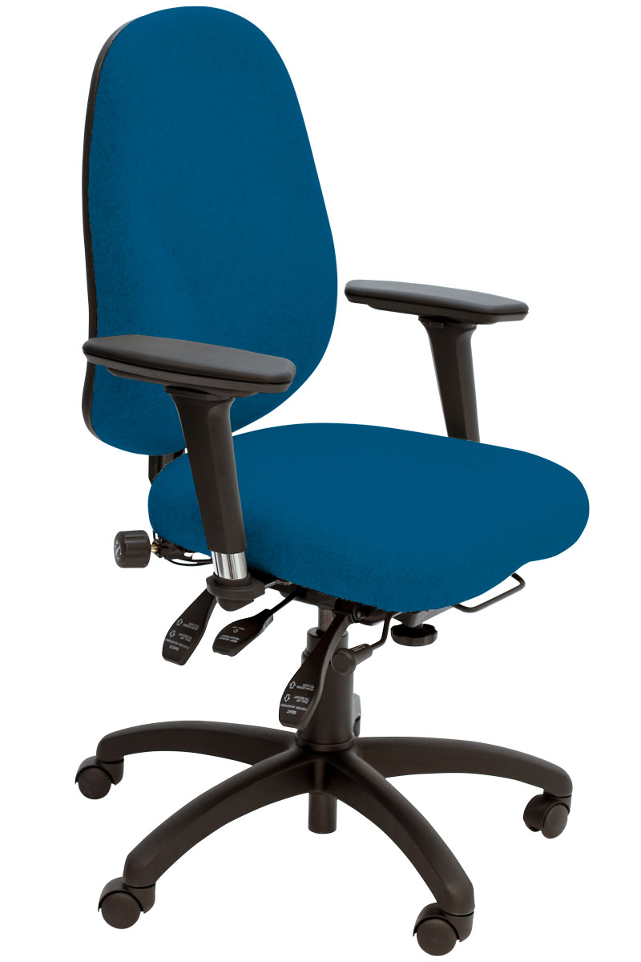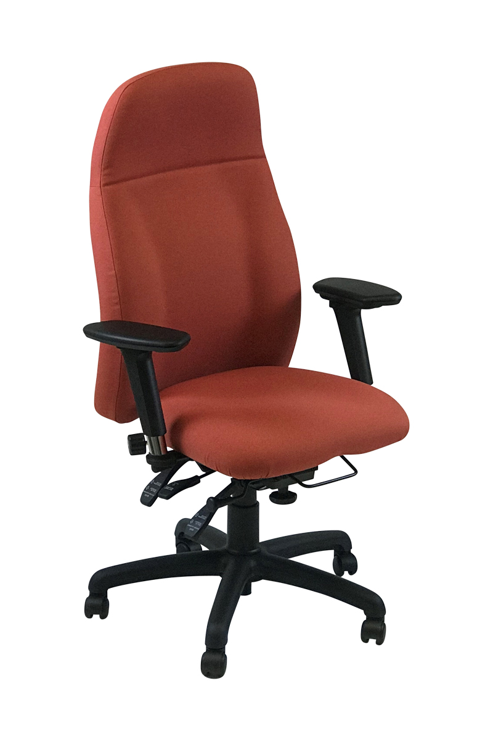

SD11

SD12

SD14

SD13

SD9

* Choice of 6 contoured backs with 2 way built-in adjustable lumbar support. Memory foam version optional.
* Comfort and support is provided by moulded CMHR foams, the double waterfall seat with thick memory foam layer
* 4-way height adjustable arms - adjustable for: height, depth, width and swivel. Other arm options are also available.
* Heavy duty 6-way adjustable mechanism adjustable for: seat depth, seat height, tilt and tilt tension and back rest height (ratchet) and tilt.
* 5 year warranty for 8 hour average daily use by up to 23.5 stone users (150kg) for single user application
* Options include: coccyx relief cut out, 6 different seat sizes, a wide choice of arms and 2 types of head/neck rests
* Please refer to our SPYNAMICS Sellers Guides for the full range of options available

**In response to customer demand, the SPYNAMICS range now includes models of chairs which are more in keeping with the look of standard operator**, task and executive chairs. Six of our UNI chairs have been enhanced with the fitting of the Spynamics mechanism, the two way adjustable lumbar, the addition of memory foam on the double-waterfall UNI seat and finished off with multifunctional height adjustable arms.

The SD9 to SD14 provide an everyday access to work solution where price is more of an issue. SPYNAMICS provides the ultimate and complete seating solution to bad back problems in the office.

SD10

For further information, please call our sales office on **01494 464656**, or fax **01494 474760**

e-mail: sales@albionchairs.com www.albionchairs.com