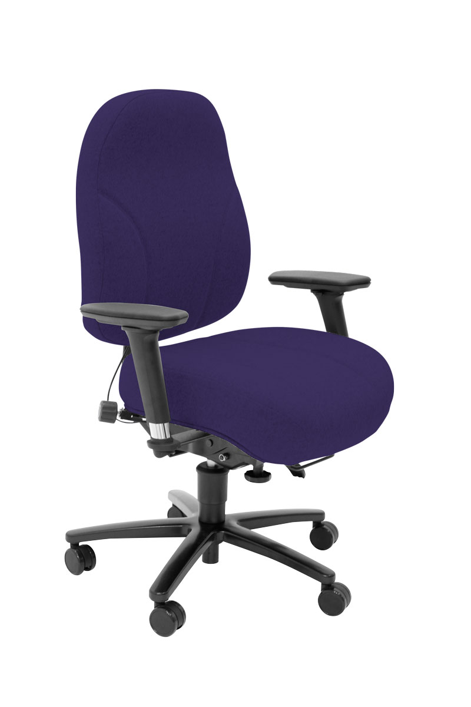



For further information, please call our sales office on **01494 464656**, or fax **01494 474760**

e-mail: sales@albionchairs.com www.albionchairs.com

The GRANDE Range   
for **up to 30 Stone (190kg)** users

G+6HR

G+6

**Grande**

t

for the LARGER and TALLER user

G+5

G+1

**Specifically developed for the taller and larger than average users of up to 30 stones (190kg),** the GRANDE range has extra-large memory foam seats and backs, 2 way adjustable lumbar support, 6-way adjustable mechanism, heavy duty flexible PU arms with spring steel inserts or height adjustable arms.

* GRANDE provides optimum adjustable support and comfort for up to 30 stone (190kg) users; all models have a metal 5 star base for increased stability.
* Extra-large memory foam seat on G+1, and G+5 (with memory foam back)
* G+1 model has a height adjustable headrest for back height 800mm+
* G+5 high back and G+6 task back will suit the less tall larger user, optional headrest (G+6HR)
* G+6 has memory foam seat and back. Seat with optional coccyx cut out
* The ergonomic mechanism has an infinite locking forward tilt, independent back rake, seat height and depth adjustment, weight tension control and ratchet backrest height adjustment
* Tested by FIRA for severe and intense contract use
* 5 year guarantee for normal 8 hour average use for up to 30 stone users
* 2 year guarantee for 24/7 multi user shift pattern use