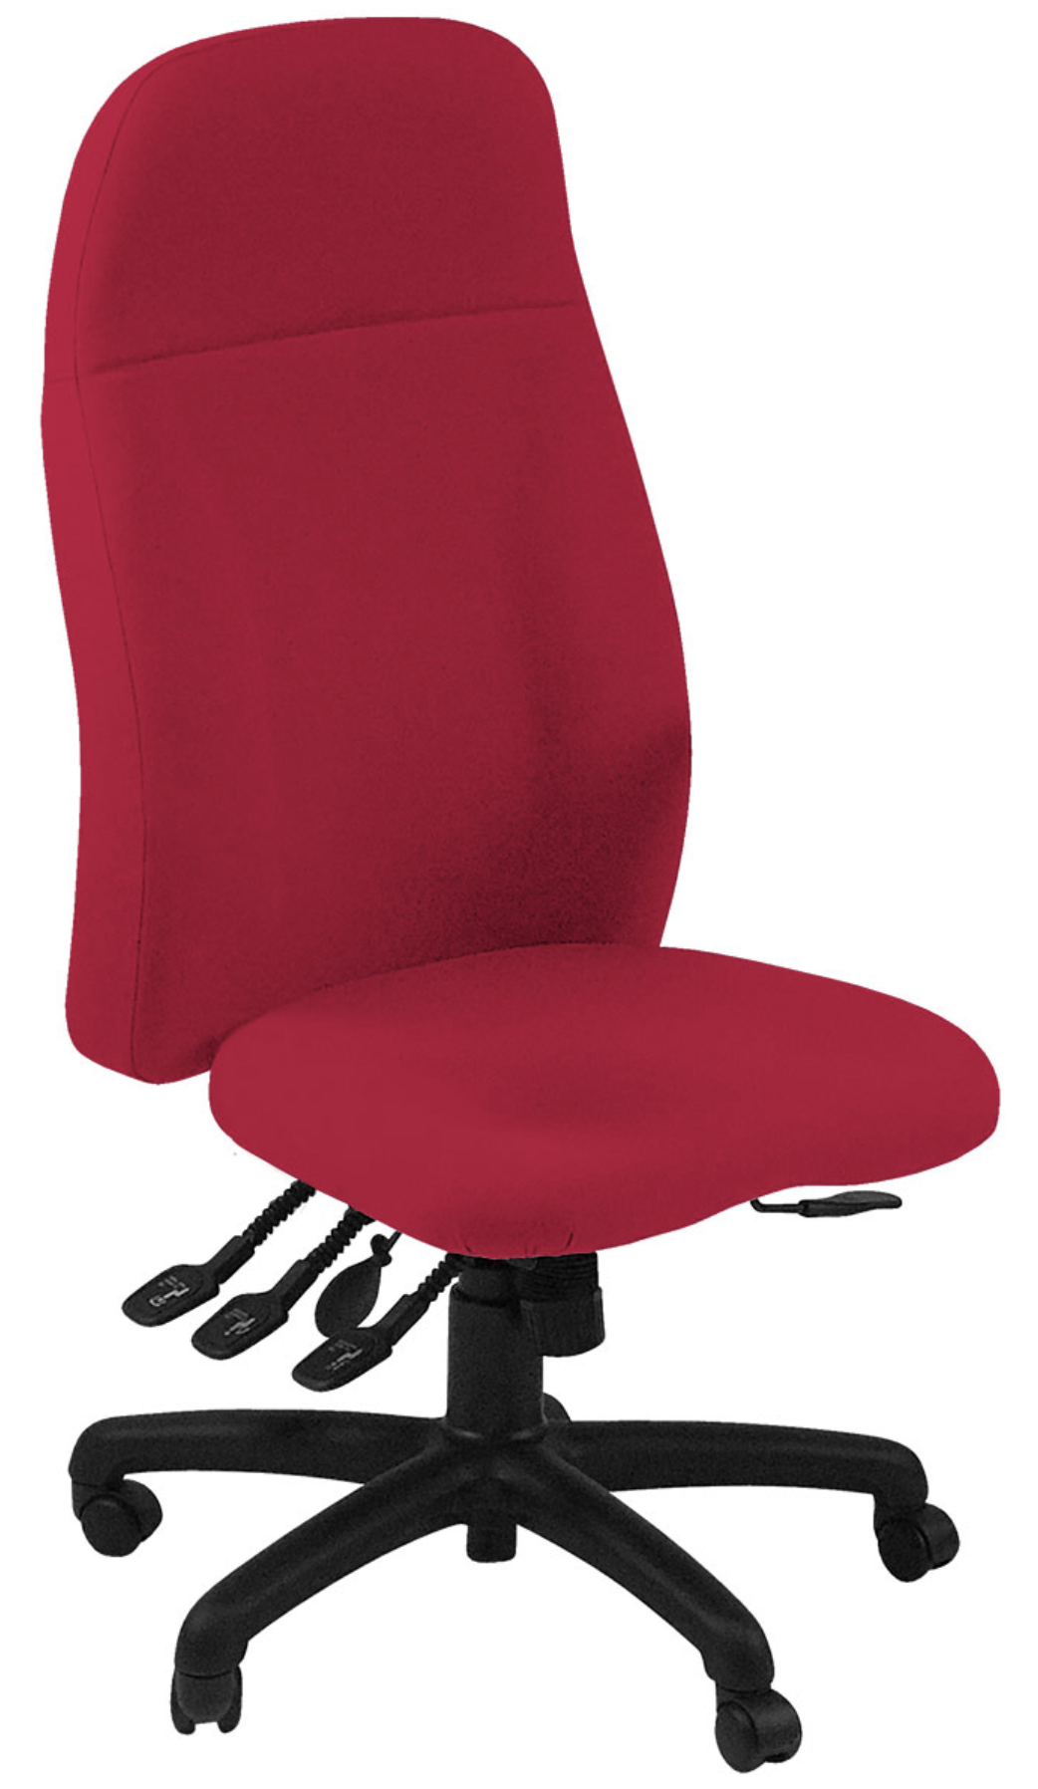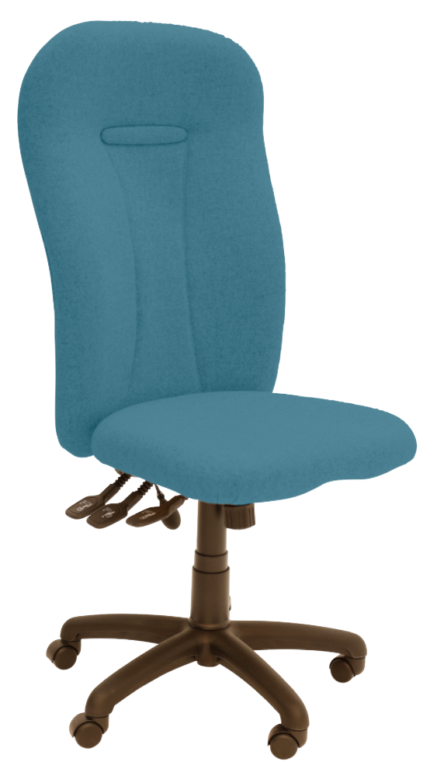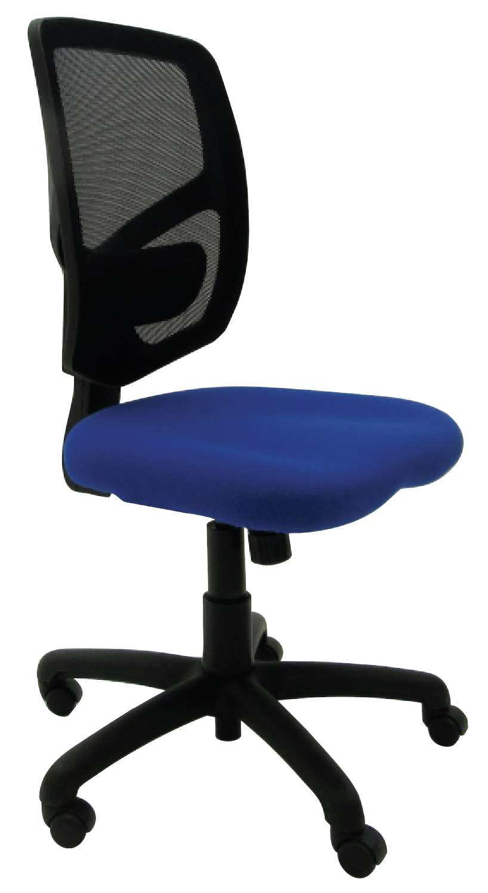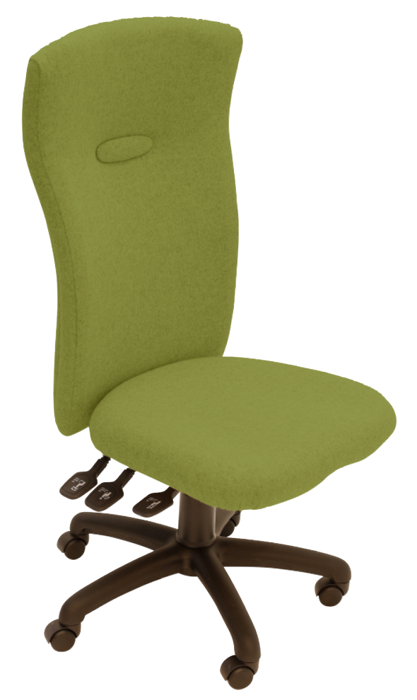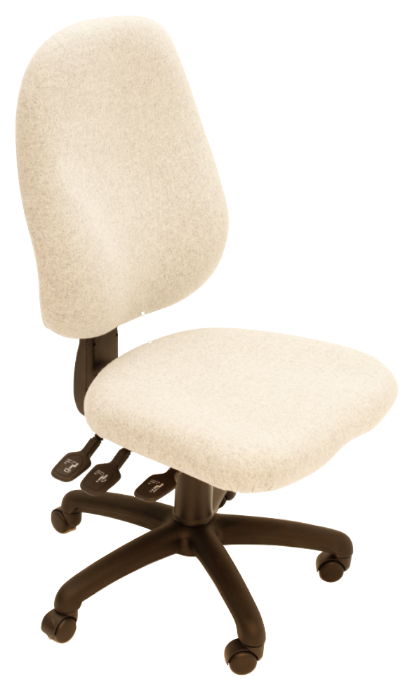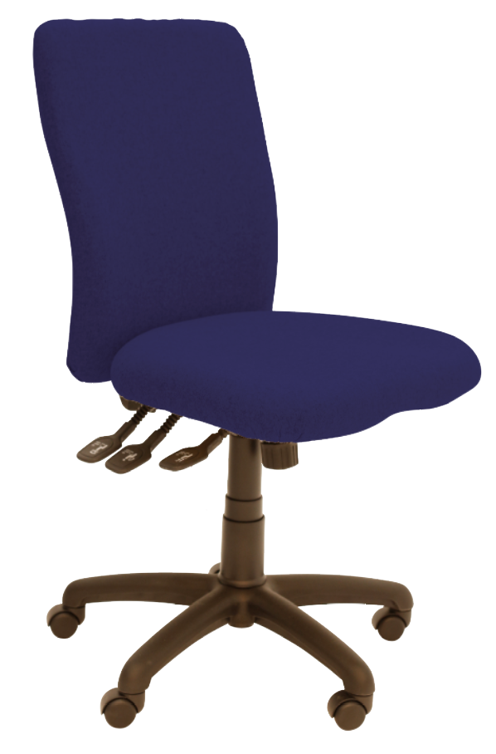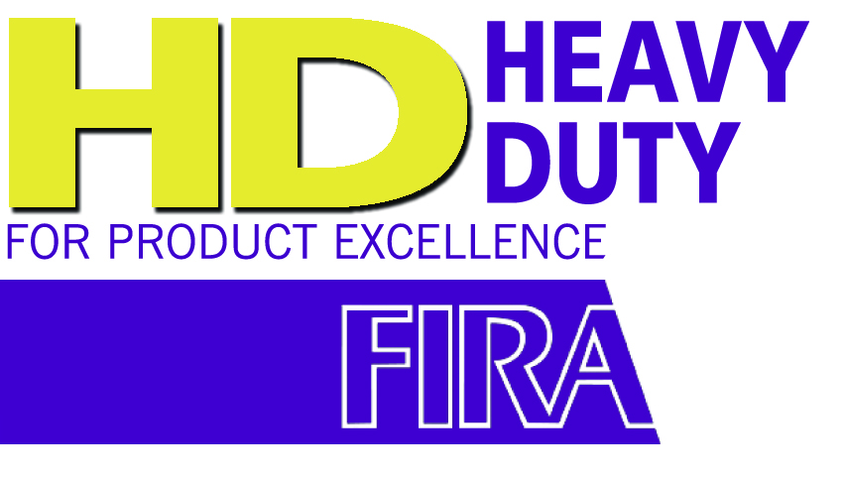

Uni95

Uni125

**The UNI12 back comes fitted with pivoting foamed lumbar

From our UNI range**, the EXEC offers a choice of 6 high backs and the Heavy Duty (HD) three lever mechanism with seat tilt, adjustable tension control and ratchet backrest height adjustment.** As with the UNI-everyday choices, these chairs can be configured to your exact requirements: with a sliding seat, a two way adjustable lumbar**, a memory foam seat, coccyx cut out, a choice of height adjustable arms and a chrome or silver base.

* Tested by FIRA to BS5459 Part 2 Test Level S for severe contract use
* **Heavy Duty (HD) rated PCB and synchro mechanisms** also available
* Fully ergonomic and **exceeds all minimum VDU requirements**
* **5 year warranty for 8 hour average use** by up to 23.5 stone (150kg) users
* Backs can be fitted with headrest if required
* **Wide choice of arms**: height adjustable / folding / retractable / multifunctional / swivel
* Optimal sized moulded seat with double waterfall front supplied with memory foam and/or coccyx cut-out if required
* Other seats available both for the taller and smaller user
* Seat height 430-550mm, footprint 700 x 700, overall height from 1000 to 1400mm

Uni65

Uni75

Uni55

High Back Executive Seating

Uni85

**Uni-Exec**

t

For further information, please call our sales office on **01494 464656**, or fax **01494 474760**

e-mail: sales@albionchairs.com www.albionchairs.com