­­­

F units, adaptable as required

Available with separate seat upholstery to allow for two tone colours.

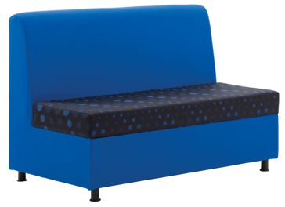

**F2**

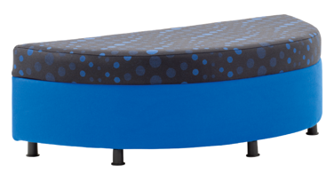

**F5**

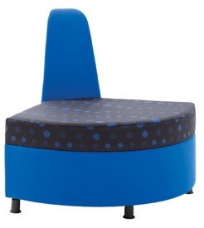

**F4**

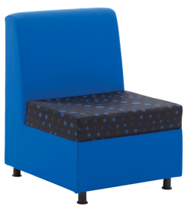

**F1**

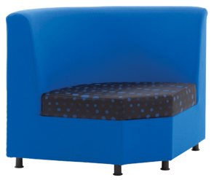

**F3**

Reception Unit Seating

**Reflex Range**

t

For further information, please call our sales office on **01494 464656**, or fax **01494 474760**

e-mail: sales@albionchairs.com www.albionchairs.com