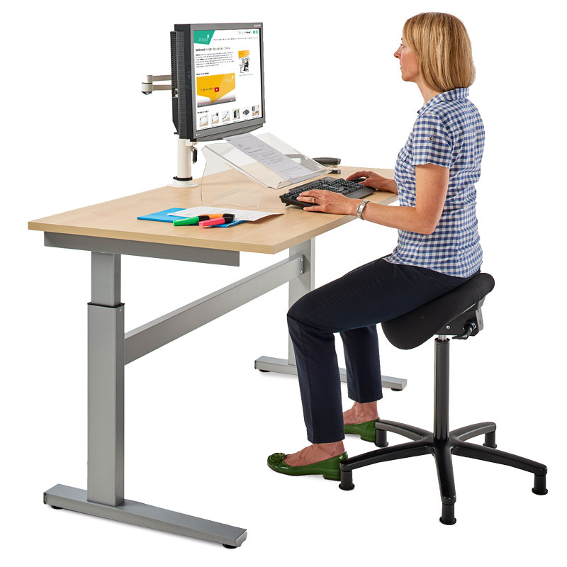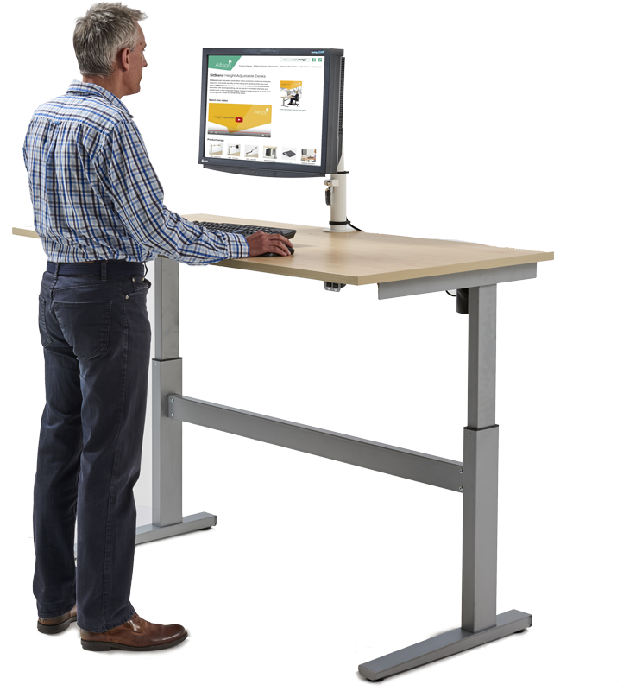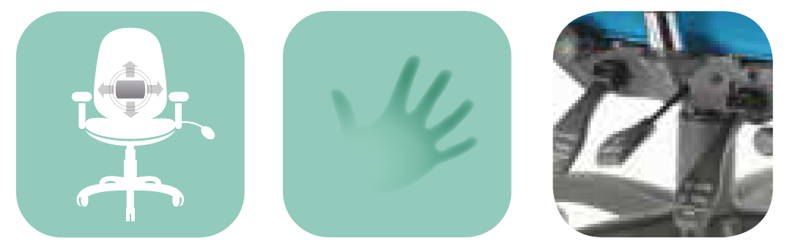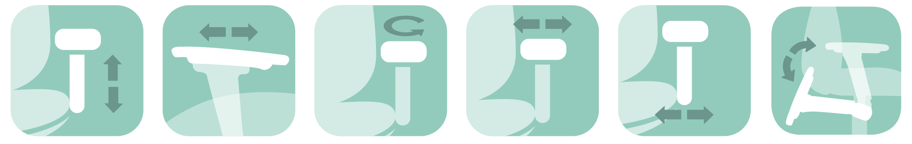

* 2, 3, 4, 5, and 6 way adjustable multifunctional height adjustable arms achieve the arm support you need no matter the desk you work at.

**Ergonomic Solutions**

* Whether your problem is in the coccyx, pelvic, lumbar, thoracic or cervical area, we offer the back shape, head/neckrest and pneumatic/mechanical lumbar/pump and memory foam upholstery to suit your personal support requirements.
* The most adjustable heavy duty mechanism available; our 6 way adjustable Spynamics mechanism has the greatest range of infinite lock of seat and back tilt on the market with: ratchet backrest height, seat slide (depth) and tilt tension

Foldaway  
arm

Adjustable   
seat width

Adjustable

armpad width

Adjustable   
swivel

Adjustable  
slide

Height adjustable arm

Spynamics  
mechanism

Pneumatic pump and mechanical 2 way lumbar

Memory

foam

Made to   
order back



Made to   
order seat

For further information, please call our sales office on **01494 464656**, or fax **01494 474760**

e-mail: sales@albionchairs.com www.albionchairs.com

**SPYNAMICS** is synonymous with ergonomic and orthopaedic seating in the workplace. The result of a collaboration in 1999 between Albion Chairs and a leading osteopath, **SPYNAMICS** was developed for users with chronic bad backs. Since then, it has continued to evolve as practitioners and users have contributed to our knowledge pool.

With our dealers, we have extended our workstation assessment service to provide an at-your-desk evaluation. We can provide a made to order chair by taking your seated measurements. This includes looking at desk layout, monitor height, keyboard and mouse accessibility and footrest requirement. We also advise on the need for an electric sit/stand desk.

Workstation assessments