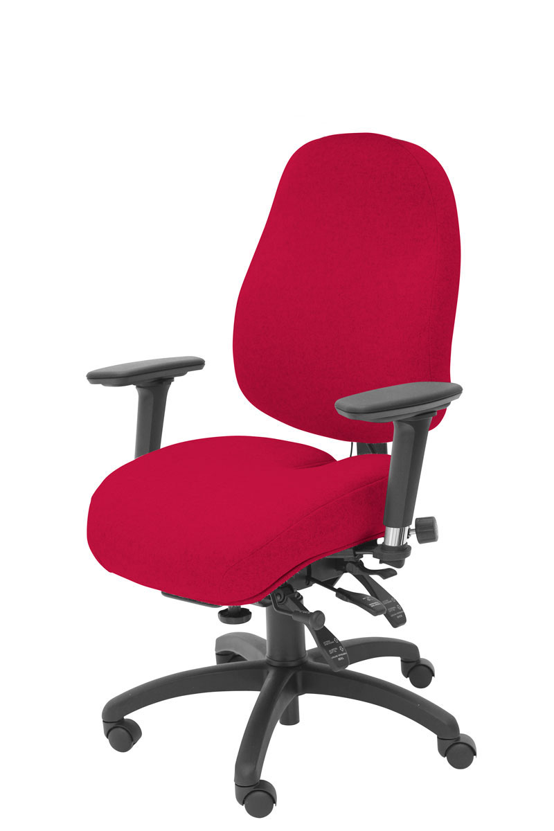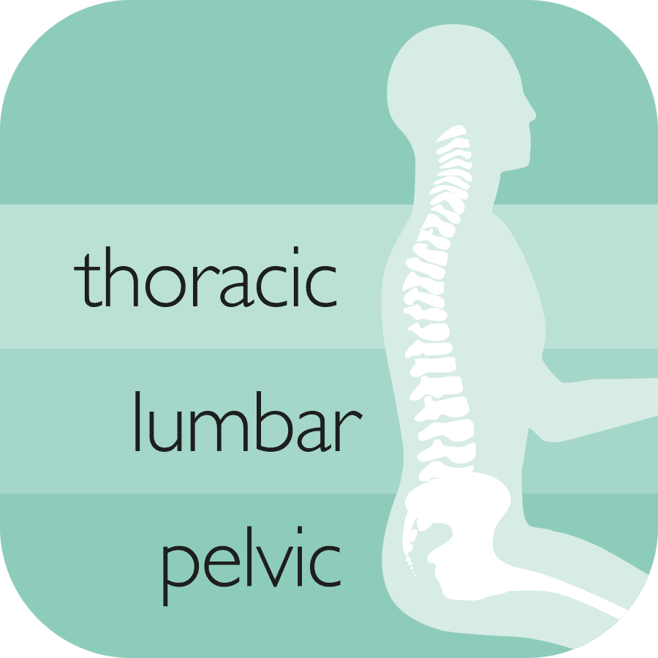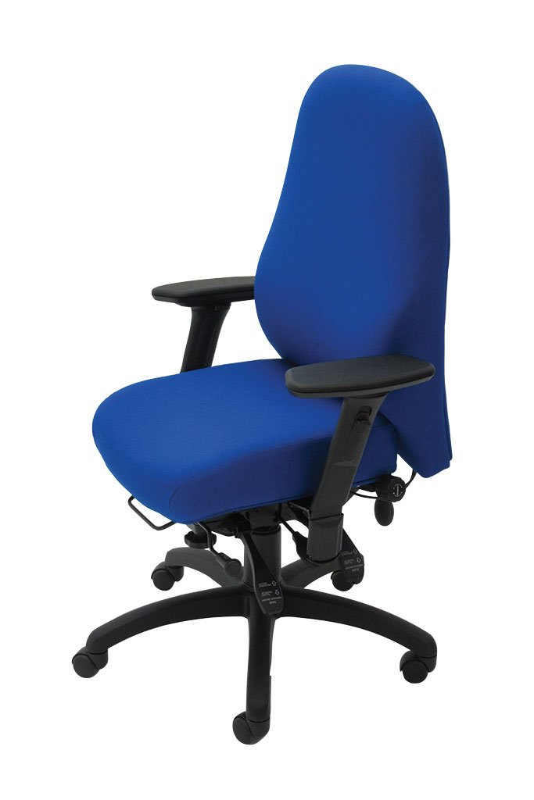

Other ergonomic features include:

* 6-way adjustable forward tilting mechanism: adjustable for seat tilt, depth, height, tension (weight) control, backrest height (ratchet) and tilt
* 5 or 6-way adjustable memory foam-upholstered arms; adjustable for: height, depth (forward and back), width and (locking) swivel
* 3-year guarantee for use by up to 150kg/23.5 stone users in 24/7 situations
* Other seat sizes and arms available on request

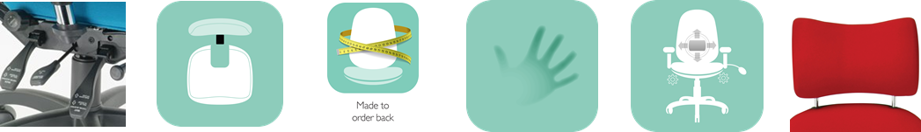

The **SD6** comes in one of two versions; with more (NSSD6) or less (SD6) pelvic support. Both have 3-way adjustable lumbar, thoracic pump and memory foam seat & back.

It can be specified with or without headrest, optional coccyx relief cut out and new FA6 6 way adjustable foldaway arms. Both can be made to measure too.

SD6CC

NASD6FA6

All-Rounder Back Care

**SD6**

For more information and prices, please contact **Phil Pask** on **07803 120155**