

Chronic Back Pain Seating

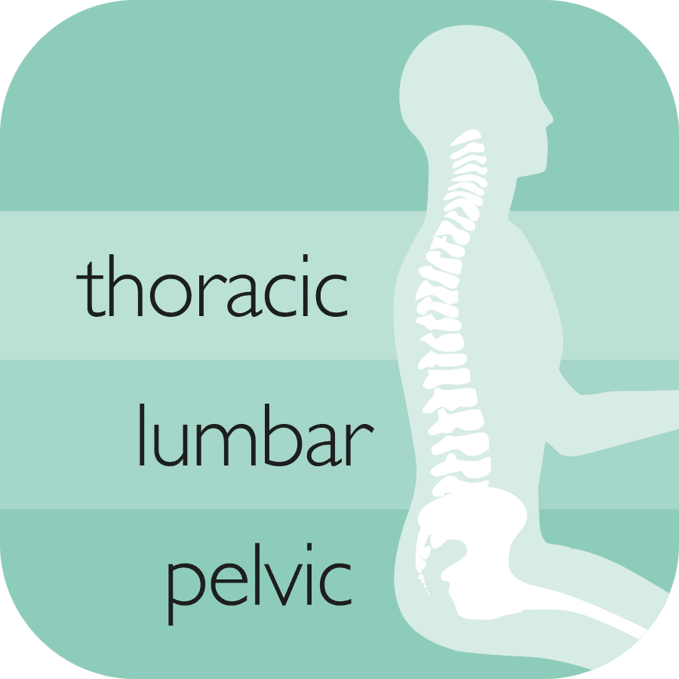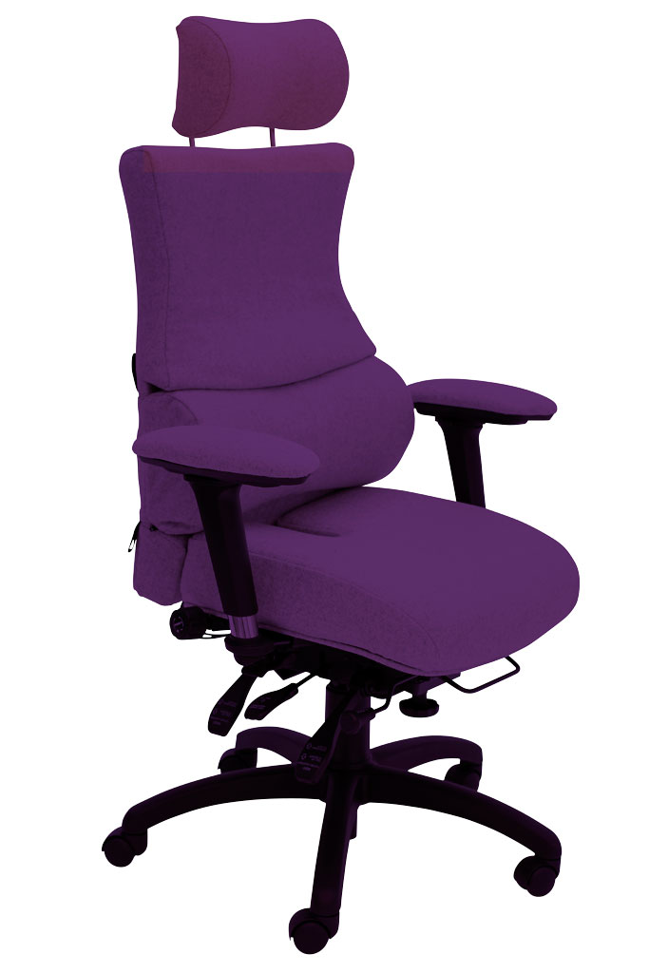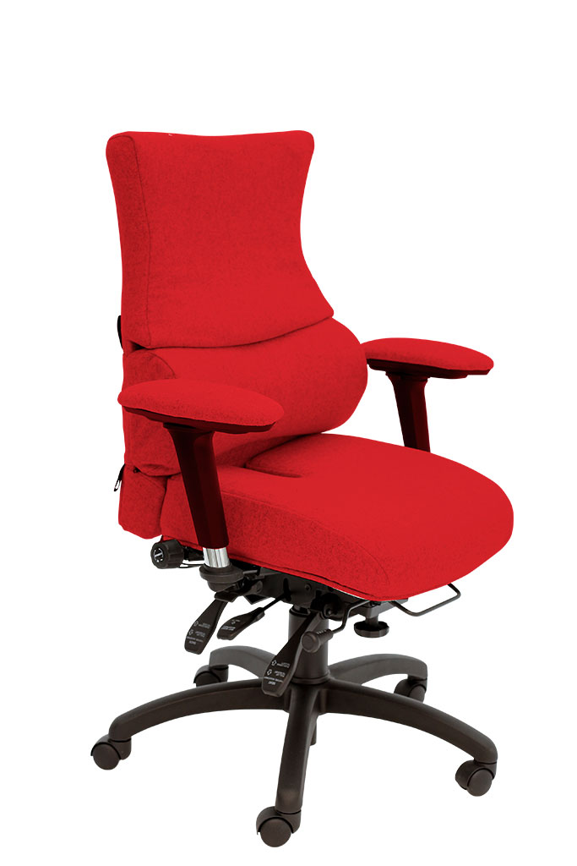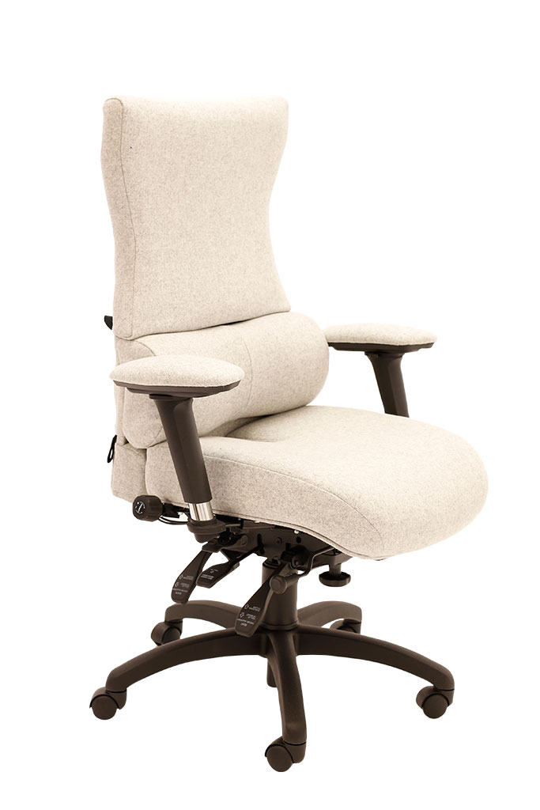

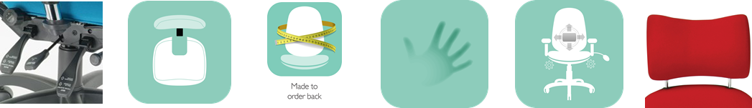

1. The **triangulation of support** provided by the personalisable pelvic cushion, the 3 way adjustable lumbar and the Thoracic pump
2. The **coccyx relief cut out**
3. The use of **memory foam**

SD3 High Back with Headrest

**SD1 SD2 SD3**

Each chair is designed in a **modular fashion** to ensure each key area of the spine receives **optimal support**. The unique features are:

SD2 High Back

SD1 Extra High Back

Other ergonomic features include:

* 6-way adjustable forward tilting mechanism: adjustable for seat tilt, depth, height, tension (weight) control, backrest height (ratchet) and tilt
* 6 seats to complement 2 back configurations including height and tilt adjustable headrest for custom built comfort
* 5-way adjustable memory foam-upholstered arms; adjustable for: height, depth (forward and back), width and (locking) swivel

For more information and prices, please contact **Phil Pask** on **07803 120155**