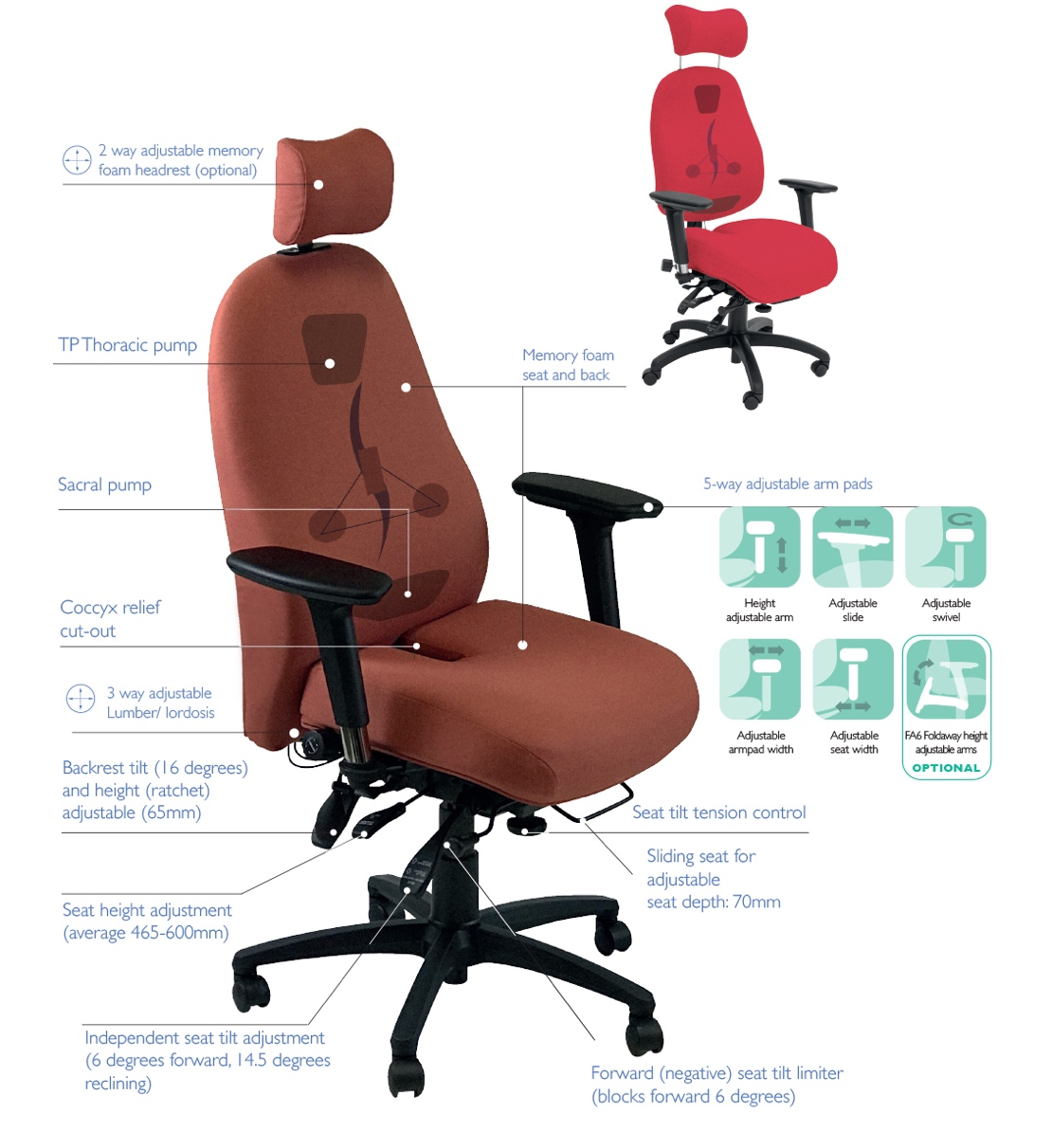
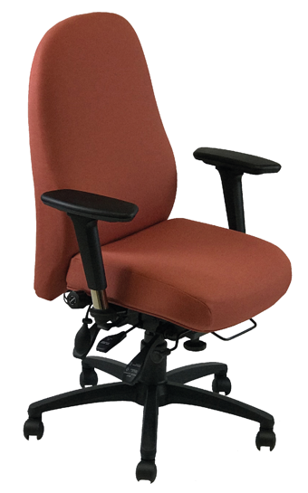
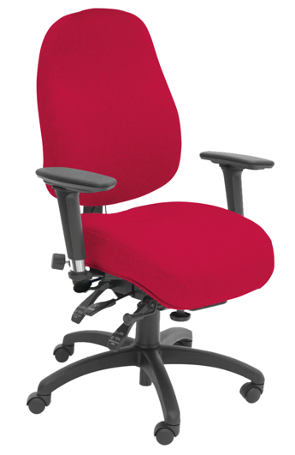
The SD6 comes in one of two versions; with more (NSSD6) or less (SD6) pelvic support. The visual appearance is intentionally more conventional to blend a little bit more into the general office environment and to not draw too much attention to the end user. No compromise is made to the bad back support features; both versions have pelvic support, sacral pump, 3-way adjustable lumbar, thoracic pump and memory foam seat & back.
SD6CCHR2
NSSD6CCHR2
NSSD6
SD6
SD6 NSSD6
All-rounder Back Care
For more information and prices, please contact Phil Pask on 07803 120155

Either can be specified with or without headrest, with or without coccyx relief cut out and both accommodate made to measure seat or back too.
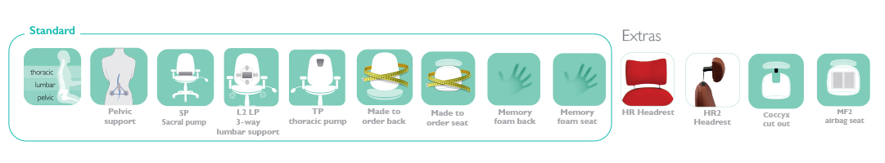

Other ergonomic features include:

- Pelvic, lumbar and thoracic support
- Use of memory foam in seat and back
- 6-way adjustable forward tilting mechanism: adjustable for seat tilt, depth, height, tension (weight) control, backrest height (ratchet) and tilt
- 5-way adjustable arms; adjustable for: height, depth (forward and back), width and (locking) swivel
- 3-year guarantee for use by up to 150kg/23.5 stone users in 24/7 situations

