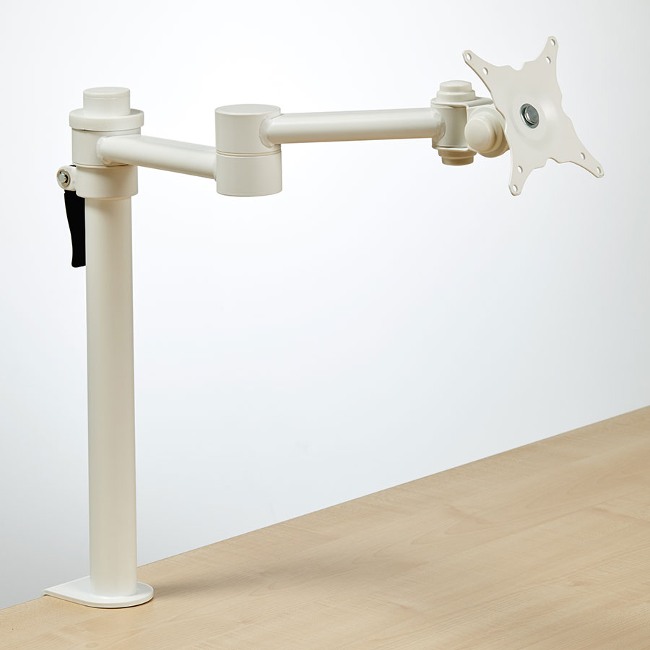**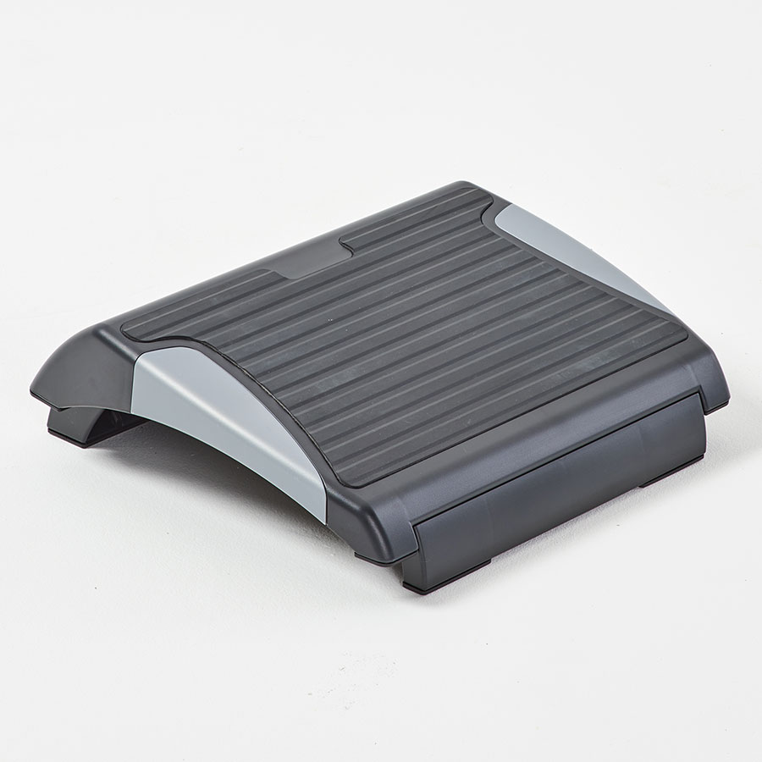

**MADE TO MEASURE SEATS AND BACKS**



Advantages of Virtual Workstation Assessments:

* **Time savings** in organising a single virtual assessment, rather than organising along with other work-related travel
* **Easier to cancel/re-schedule** in the event of last-minute changes
* **Greater flexibility** to carry out virtual assessments outside of normal working
* Simpler to integrate into end-user's work schedule and with **less impact on their working day**
* **Increased privacy** as end-users are more comfortable discussing personal medical conditions if not in an open office
* No compromise in obtaining **accurate understanding of the end-user's working environment**, be they at home or in the office and taking essential measurements which in turn ensures the user is provided with the right solution for their needs

For further information, please call our sales office on **01494 464656**, or fax **01494 474760**

e-mail : **sales@albionchairs.com** **www.albionchairs.com**

Home or workplace workstation assessments made easy

**Virtual Assessments**