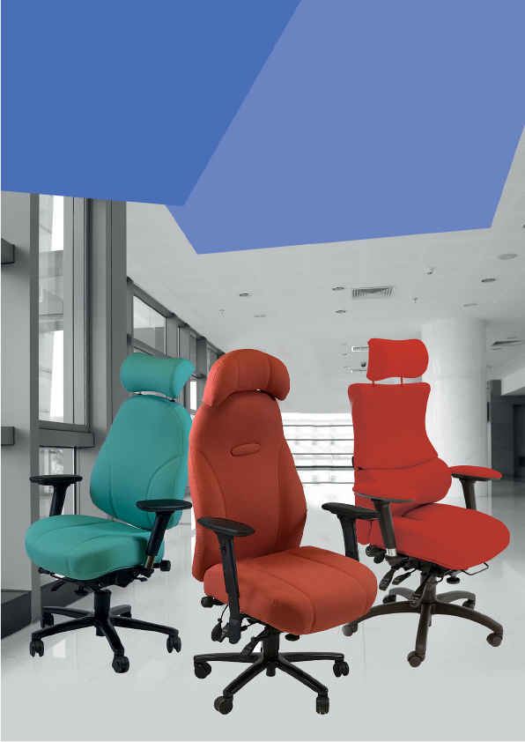

Spynamics & Grande
Retails

July 2024

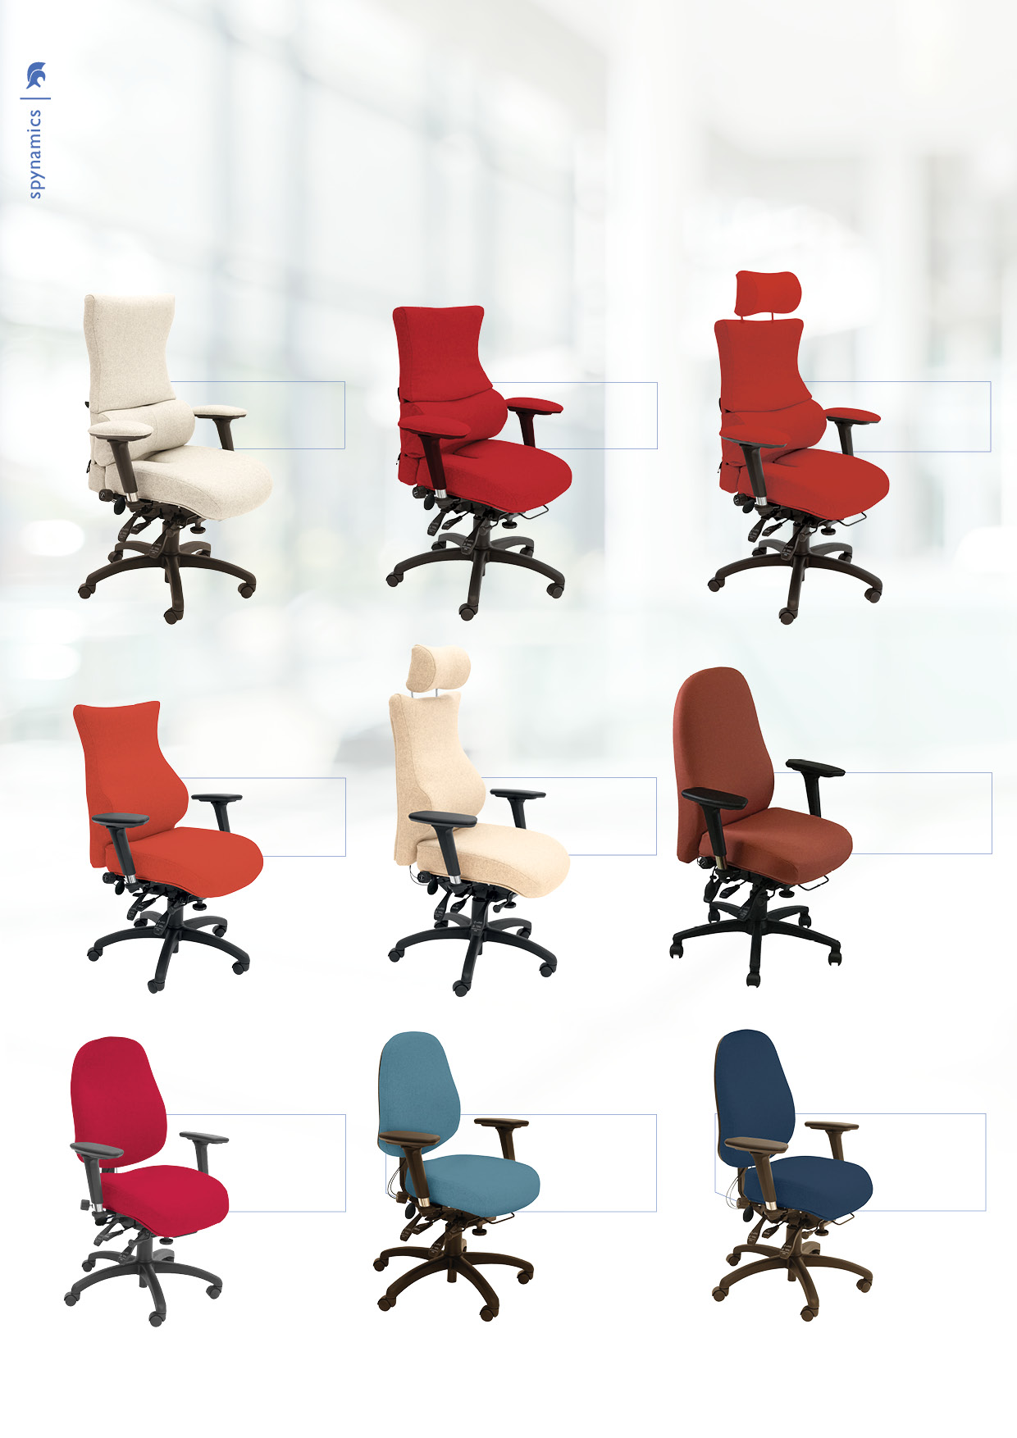
spynamics
Since its introduction in 1999, Spynamics has evolved from a single chair into a range of 14 preconfigured ergonomic and orthopedic chairs, that still allows you to build a bespoke, made to measure version to suit whatever personal back condition your customer may have. The Spynamics family caters for sizes ranging from 4’10” to 6’5” and up to 23.5 stone (150kg). For users larger than this we have the Grande range..

SD2

SD1

SD3
Xtreme+
£1491.36

Xtreme+
£1340.78

Xtreme+
£1340.78

Xtreme+
£1048.96

NSSD6

SD5
Xtreme+
£1199.55

SD4
Xtreme+
£955.11

SD8

SD7

SD6
Xtreme+
£773.22
Xtreme+
£664.98

Xtreme+
£955.11

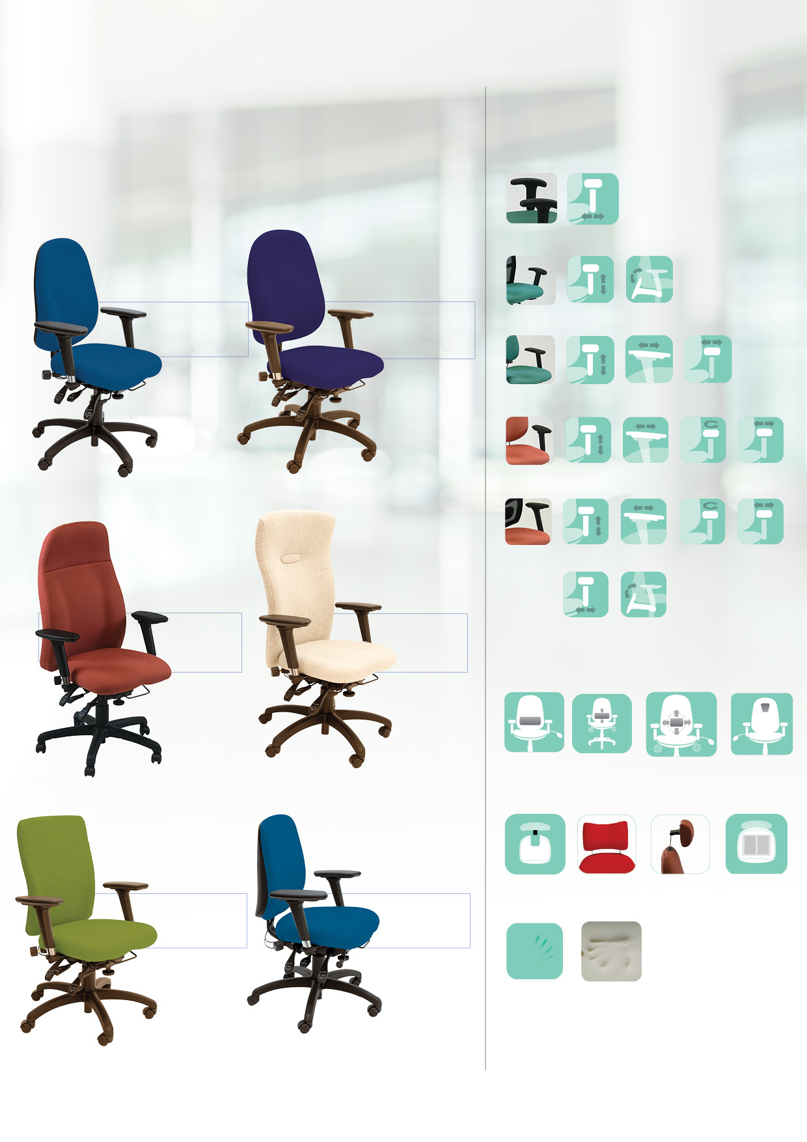
Xtreme+
£851.72

L2
lumbar
£82.80
L2 LP
3 way lumbar support
£124.20
TP
thoracic pump
£41.40
LP
lumbar pump
£41.40
MF2
airbag seat
£56.68
Made to
order back memory foam
£87.34
Made to
order seat
memory foam
£87.34
Coccyx
cut out
£49.59
HR
Headrest
£137.93
HR2
Headrest
£84.29
Xtreme+
£754.29

SD13
Xtreme+
£851.72

SD11
Xtreme+
£683.73

SD9

SD10
Xtreme+
£754.29

SD14
Xtreme+
£664.98

SD12

Other options and personalisations

Saves £32.49 on retail
Saves £32.49 on retail
Adjustable seat width
Foldaway
arm
Adjustable armpad width
Adjustable armpad width
Height adjustable arm
Adjustable
slide
Adjustable
swivel
Adjustable
slide
Adjustable
swivel
Adjustable armpad width
Foldaway
arm
Foldaway
arm
Height adjustable arm
Height adjustable arm
Height adjustable arm
Height adjustable arm
A3B Arm same price

A4X Arm standard for SD9-14

FA6 Arm option - same price

FA Arm

A Arm

If you do want to personalise a little bit more, you can choose from the arms and other options below to further enhance the functionality or appearance.
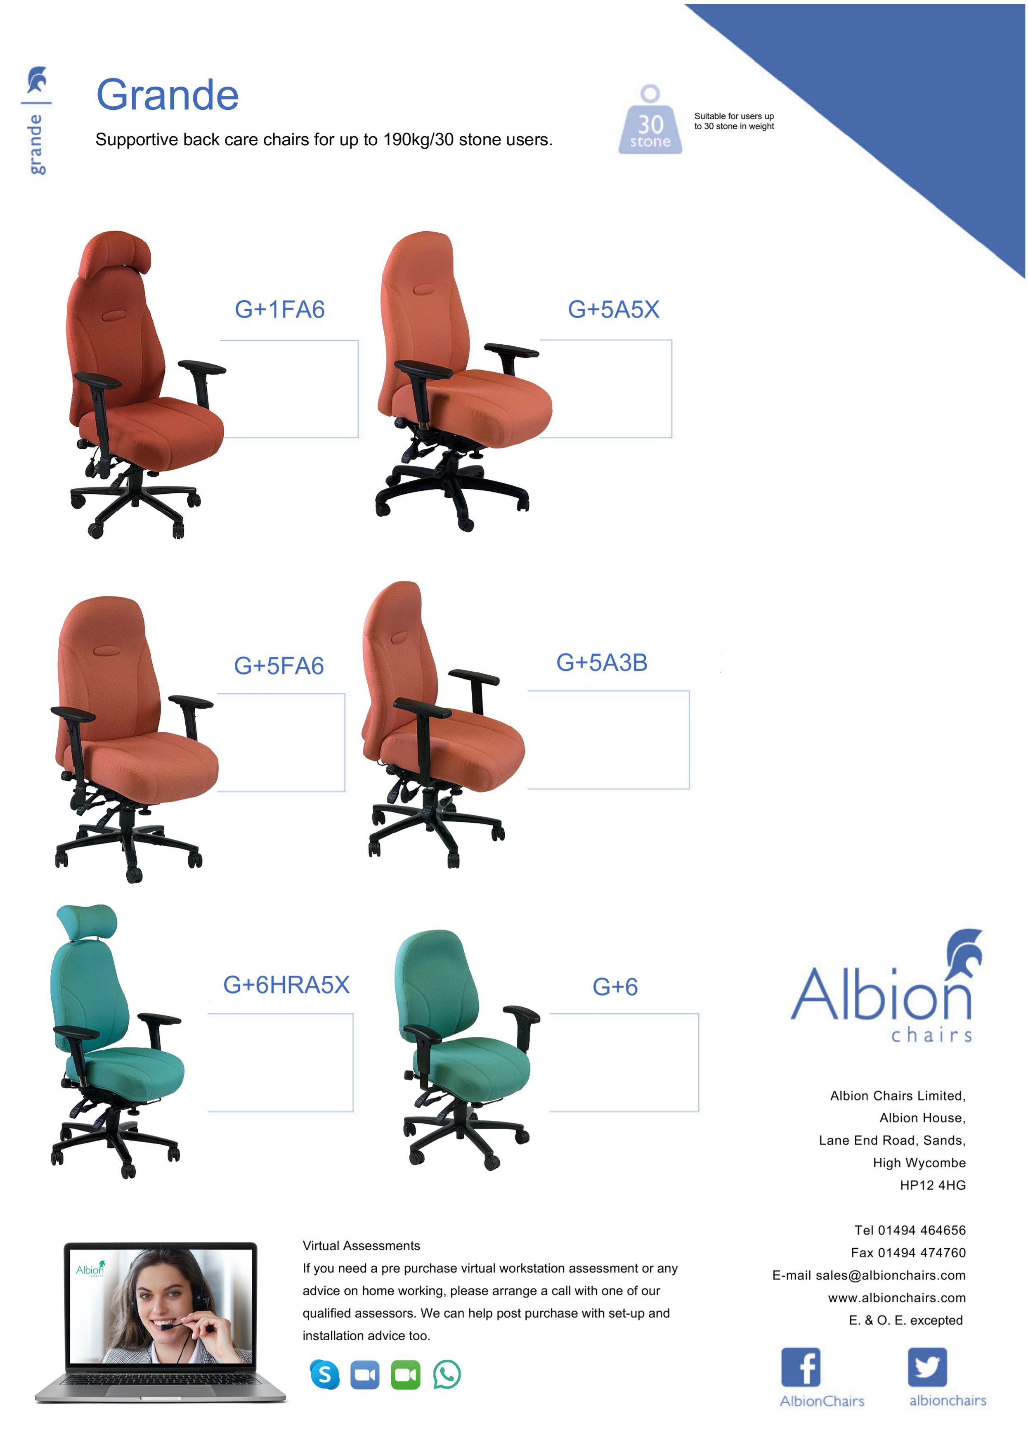
Xtreme+
£773.22
Xtreme+
£957.28
Xtreme+
£1082.43
Xtreme+
£1082.43
Xtreme+
£1082.43
Xtreme+
£1216.49

