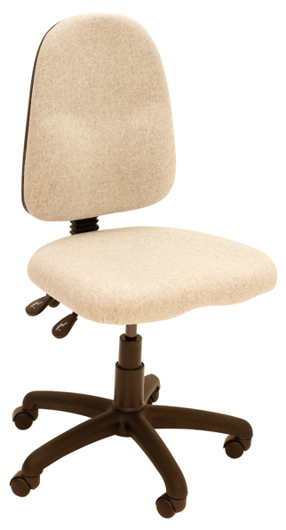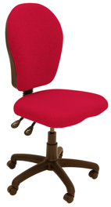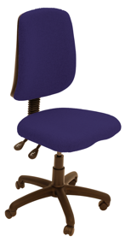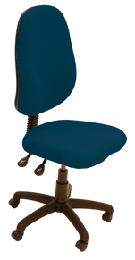

Uni17

Uni07

Uni27

Uni117

Uni37

Uni107

Uni47

The everyday side of UNI is **a comprehensive range of cost effective operator and task seating with a choice of 7 different back styles**. All models have ergonomic support, twin lever seat height and back rake adjustment with **separate back height manual wheel adjustment**. Extra options include a 3 lever independent seat and back mechanism with seat tilt, adjustable sliding seat, adjustable lumbar, ratchet backrest height adjustment, height adjustable and multifunction swivel arms; polished chrome effect or silver 5 star base, draughtsman or counter heights with foot ring/glides and a matching cantilever visitors chair option in a choice of black or chrome frames.

* Tested by FIRA to BS5459 Part 2 Test Level S for severe contract use
* Fully ergonomic and exceeds all minimum VDU requirements
* Choice of 7 supportive backs
* Comfortable moulded seat foam with double waterfall front
* 5 year guarantee for normal 8 hour average use by up to 19 stone users
* Twin lever as standard with optional 3 lever mechanism with seat tilt
* Optional upgrade to Heavy Duty (HD) mechanism for users up to 23.5 stone
* Seat height 430-550mm, footprint 700 x 700, heights 1000 to 1300mm
* Choice of a wide range of fabrics, vinyl or leather upholstery

**Uni-Everyday**

t

For further information, please call our sales office on **01494 464656**, or fax **01494 474760**

e-mail: sales@albionchairs.com www.albionchairs.com

Operator and Task Chairs