­­­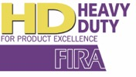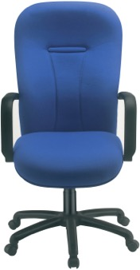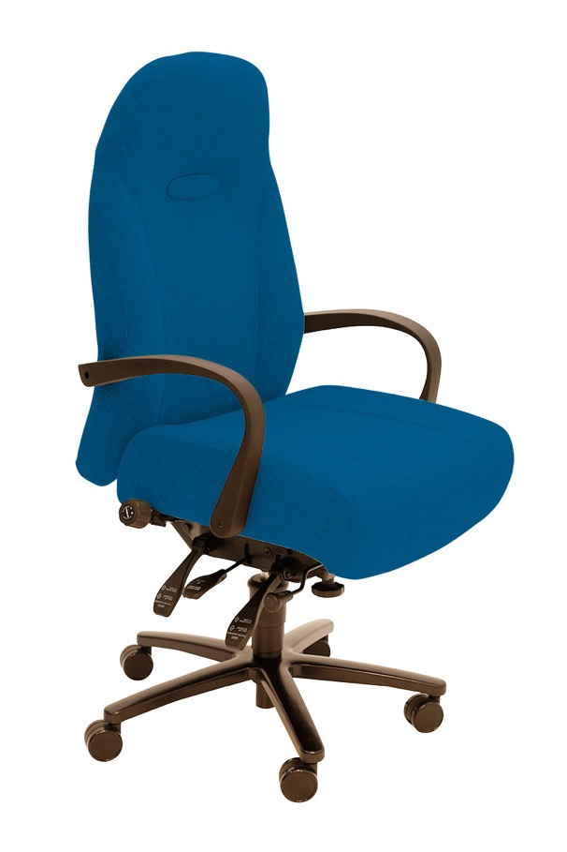­

G+5FT

P65FT

G+6A

P57FT

Perpetua provides a range of operator, task and management seating with a choice of medium, high or extra high backs for 24/7 use.

The key feature on top of the **quality and robustness** of the build is our quibble free top to toe guarantee for **5 years of 24/7 use.**

Each chair has a heavy duty 5 star base, is upholstered in 200,000+ rub tested 24/7 fabric on plywood, has a 150kgs rated gas lift, is configured with our Heavy Duty (HD) mechanisms and comes with a choice of height adjustable or spring steel insert flexi-arms.

Typical usage environments include control rooms, call centres and security guard areas but can be used in any heavy-duty area.

**Perpetua Range**

t

See also the Grande range and SD6.

For further information, please call our sales office on **01494 464656**, or fax **01494 474760**

e-mail: sales@albionchairs.com www.albionchairs.com

24 Hour Multi-Shift Pattern Seating