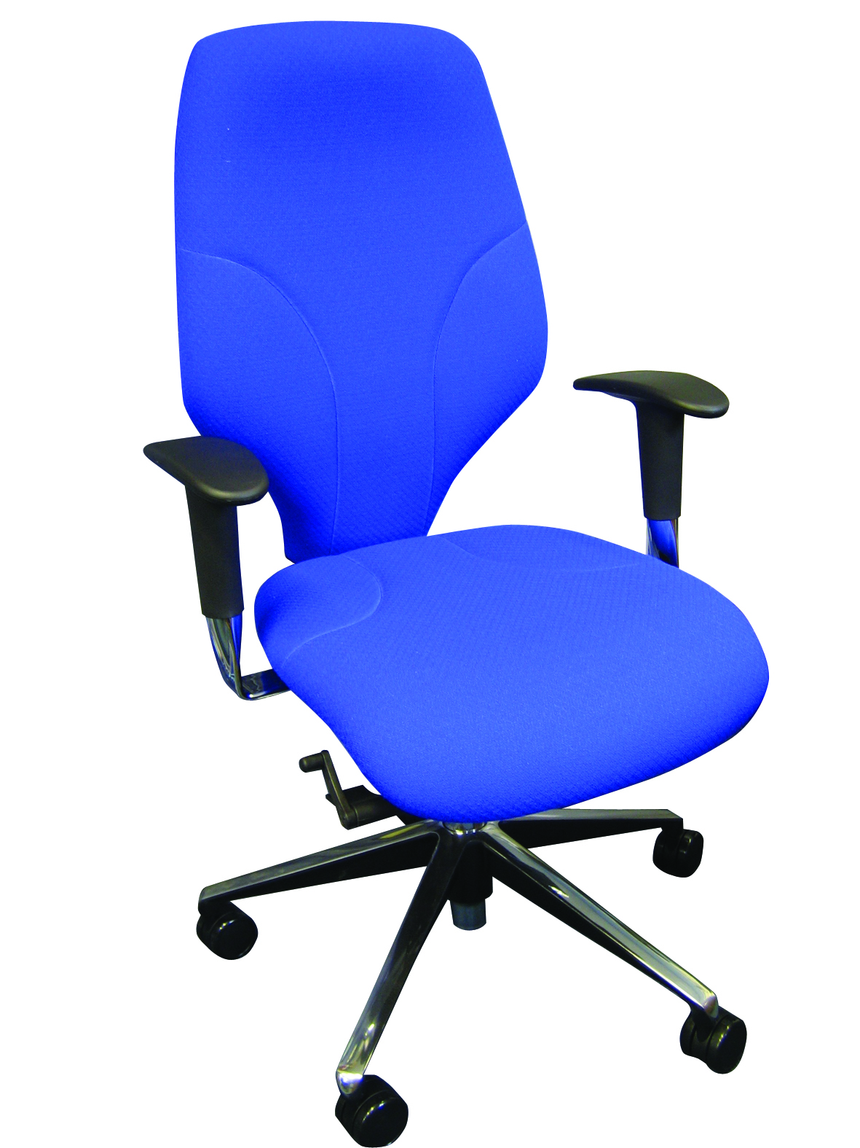

**The aim of our carbon-friendly chair is quite simply to reduce the carbon footprint of the chair and to slow down its ultimate journey to landfill.**

This is achieved by:

1. Sourcing as many of the components as is possible from UK manufacturers – minimising the carbon footprint right from the start of its working life
2. Ensuring that all its components can be easily disassembled to be recycled, reused or composted
3. Ensuring the chair will have a lifespan of at least 10 years – providing peace of mind of its mechanics, assurance of money well spent but also slowing down the ultimate journey of the chair to landfill

ALBION CHAIRS: REDUCING YOUR CARBON FOOTPRINT

Component Features:

* The chairs' base is polished aluminium and come from the West Midlands. In general, aluminium is better than plastic as it can be recycled an infinite number of times and unlike plastic does not need to be mixed with virgin material to provide its inherent strength.
* The castors cannot be anything other than plastic and come from a UK manufacturer in Norfolk.
* There are no UK manufacturers of gas lifts. Therefore, the gas lift is supplied by the closest manufacturer – Stabilus - who manufacture from their bases in Germany and Romania. The gas lift will exceed the 10-year lifespan and Stabilus can recycle them at the end of their useful lives.
* The long lasting, highly functional mechanism comes from Taiwan.
* Plywood for the seat and back frame is supplied from a company based in Bicester. Plywood is preferred over plastic for its greener credentials and strength.
* All foams are replaced by latex coated horsehair and wool and with the appropriate fabric from Camira (Mainline Flax and Oceanic) will still provide medium hazard flame retardancy with the added benefit of compostability for the life of the chair.

For further information, please call our sales office on **01494 464656**, or fax **01494 474760**

e-mail: sales@albionchairs.com www.albionchairs.com

**CFC**

t

Carbon Friendly Chair