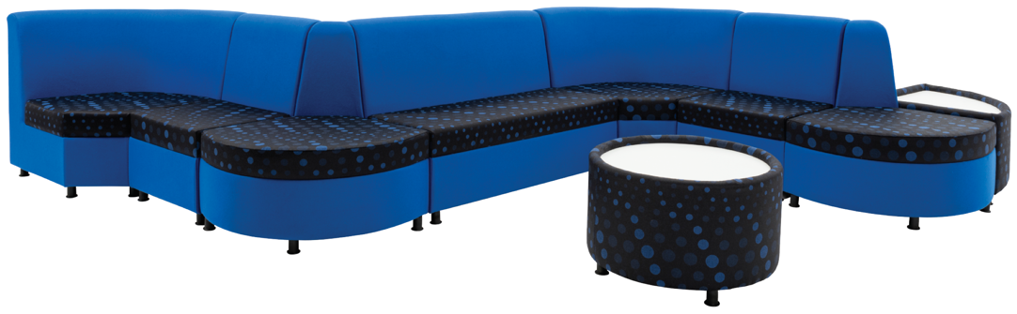­­­

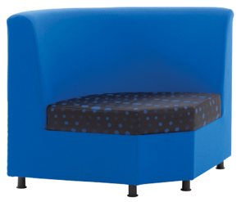

**F3**

900

650

1200

390

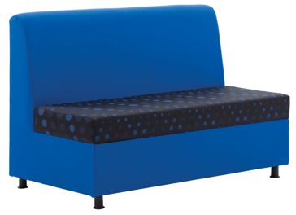

**F2**

390

650

790

1200

485

Modular Seating

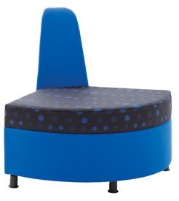

**F4**

650

580

390

900

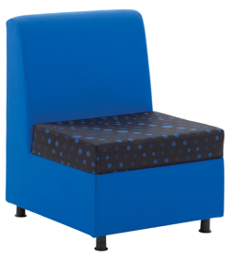

**F1**

430

485

390

790

600

650

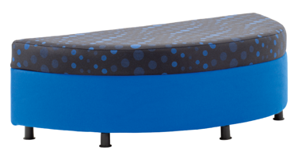

**F5**

390

1300

500

All dimensions in mm

**Reflex F**

t

For further information, please call our sales office on **01494 464656**, or fax **01494 474760**

e-mail: sales@albionchairs.com www.albionchairs.com