POU1X3

POU2X3

POU3GL

For further information, please call our sales office on **01494 464656**, or fax **01494 474760**

e-mail: sales@albionchairs.com www.albionchairs.com

**Pouffes**

t

Our pouffes are customisable on top of what you see here. If you don’t see something you need for your space let us know and we’ll make it for you!

POU4BKX3

POU5GL

POU5BKGL

POU3x2

POU3BKGL

POU4x2

For further information, please call our sales office on **01494 464656**, or fax **01494 474760**

e-mail: sales@albionchairs.com www.albionchairs.com

**Pouffes**

t



**Pouffes**

t

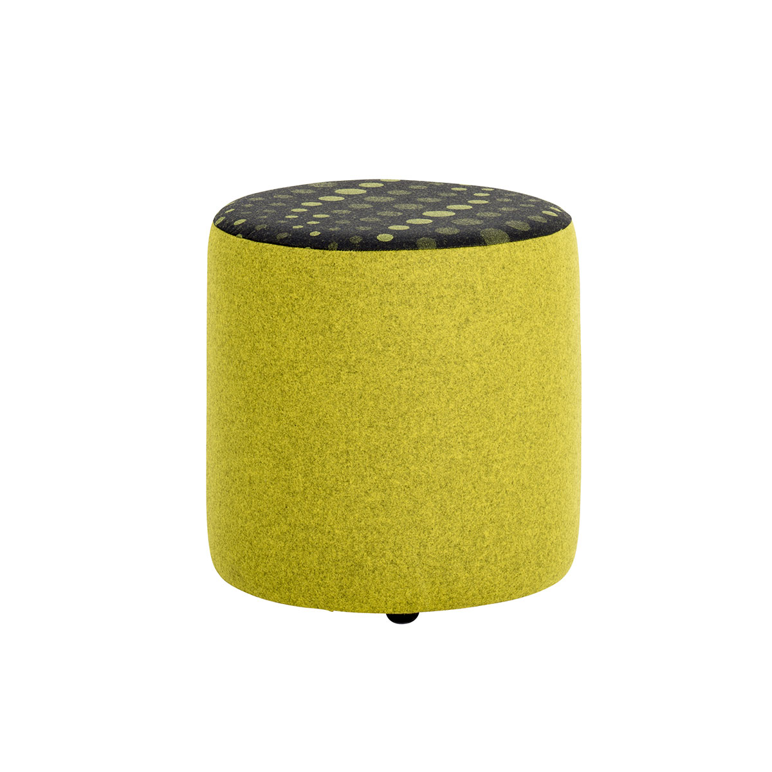

CV3GL

POU13GL

POU12x4

POU10BKGL

POU10GL

POU11GL

POU8X3

POU9GL

POU7x3

For further information, please call our sales office on **01494 464656**, or fax **01494 474760**

e-mail: sales@albionchairs.com www.albionchairs.com

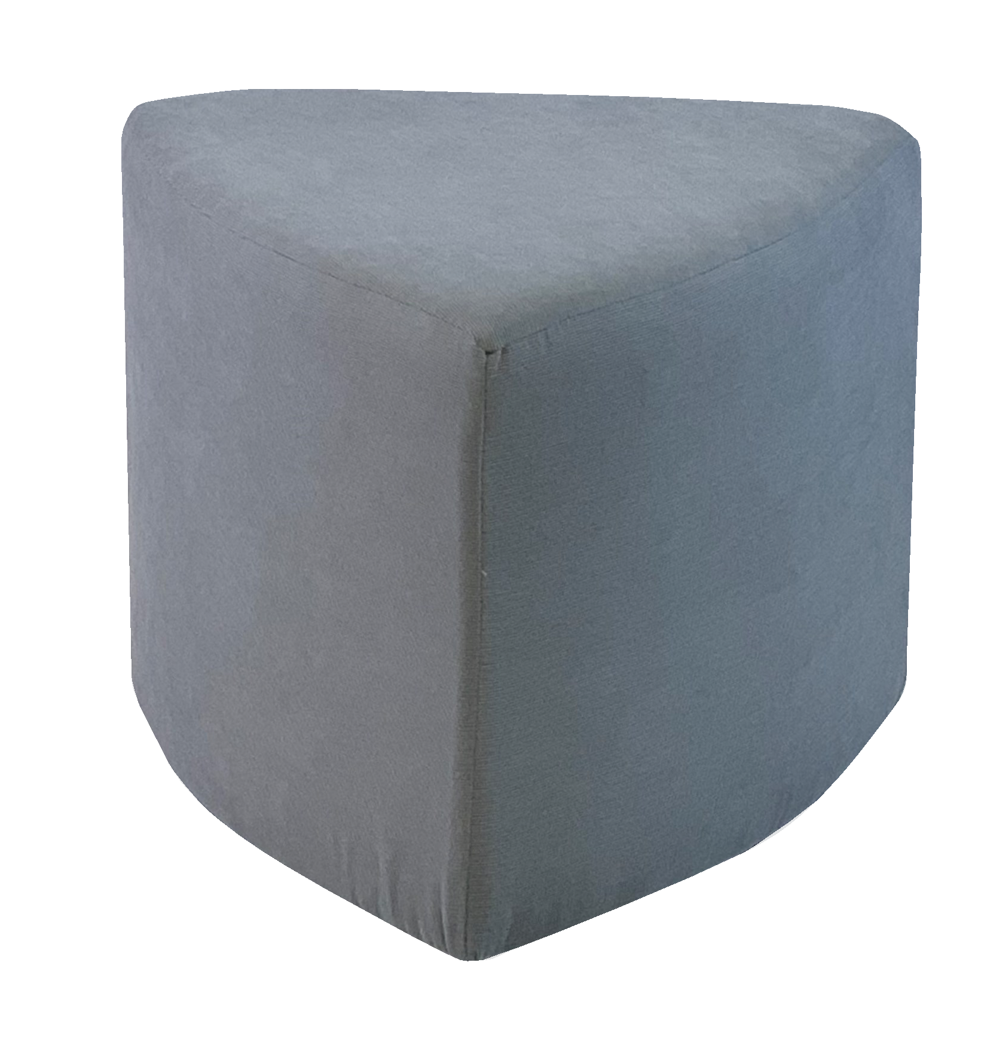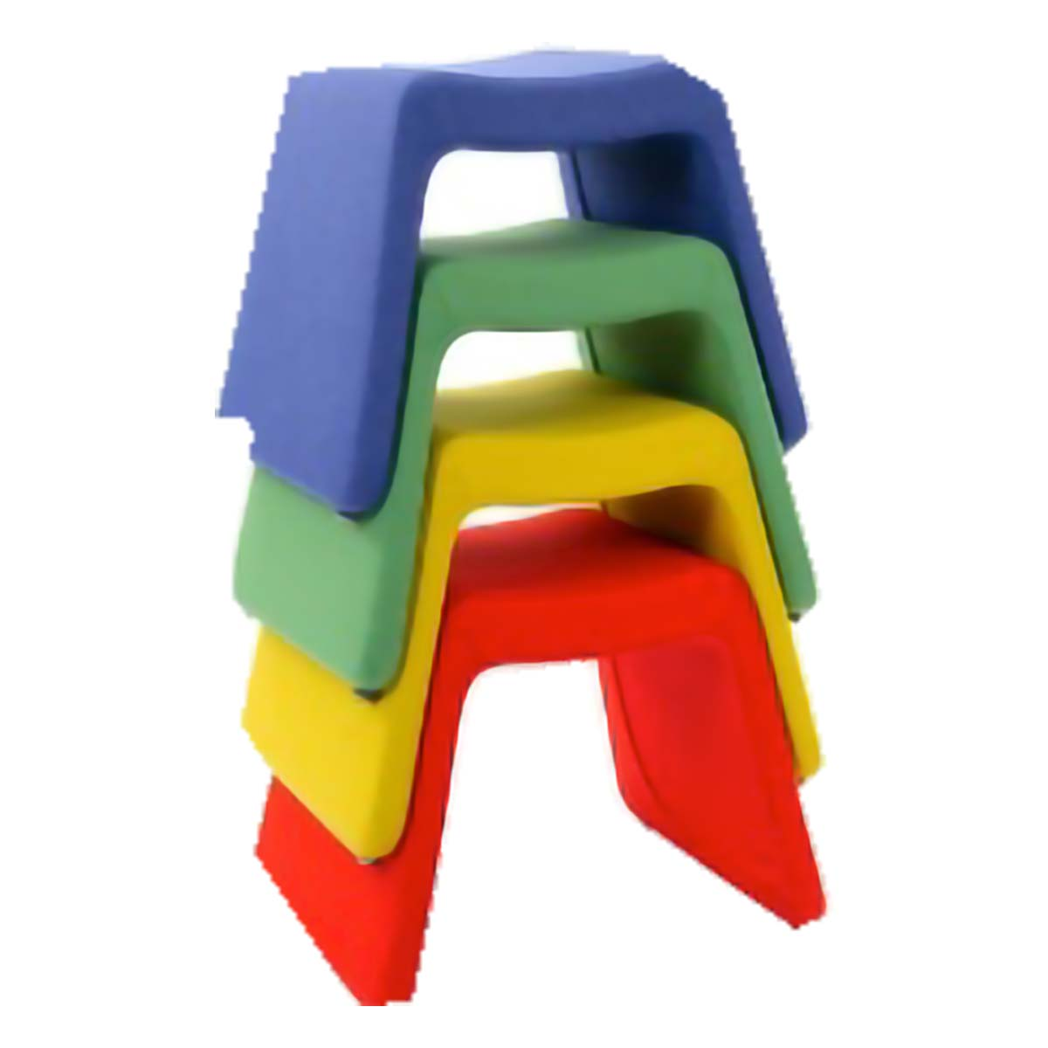

POU16GL

POU18

F5

POU14GL

POU15GL

POU17GL

**Pouffes**

t

For further information, please call our sales office on **01494 464656**, or fax **01494 474760**

e-mail: sales@albionchairs.com www.albionchairs.com